**Simplification Stage**

1. **Simplification stage for bug 1:**

In the simplification stage, I need to reproduce each bug and record the output demonstrating the buggy behavior. In this to reproduce the bug and to test the buggy behavior, I added some print statement to the code demonstrating what to expect in a particular process and what the result is. If the result is not the expected one, then it has buggy behavior. The screenshots are given below. Reported first bug was during checkout, the service charges are reported as 0.0. The below screenshots are from booking process till checkout process and it demonstrates the print statement whether it has bug or not. If it has bug then it will be printed there and bug is highlighted as well.

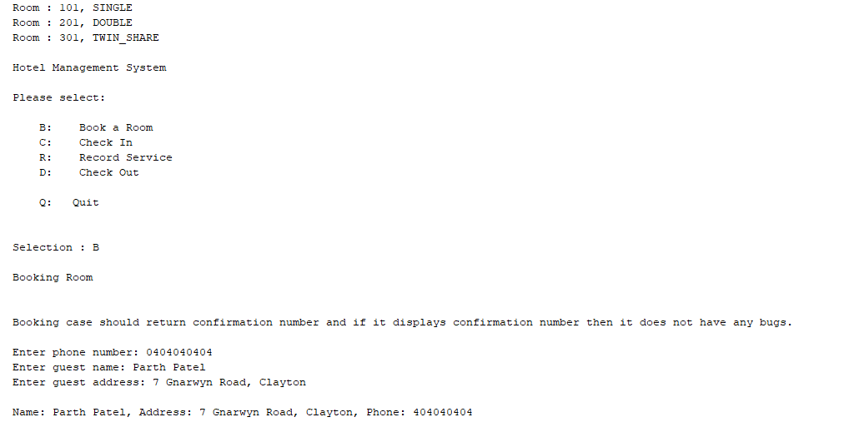

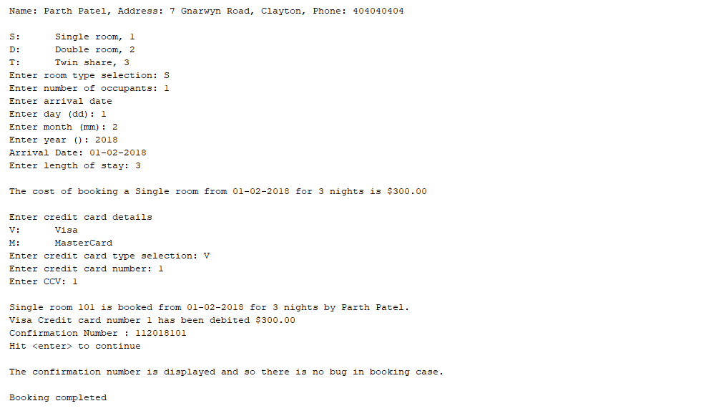

As shown in the above screenshots, the booking process should return confirmation number and it did that and s there is no bugs in booking case.

The checkin case should allow the guest to checkin and then it should change the state of the room to checked in. The screenshot of checkin case testing is given below.

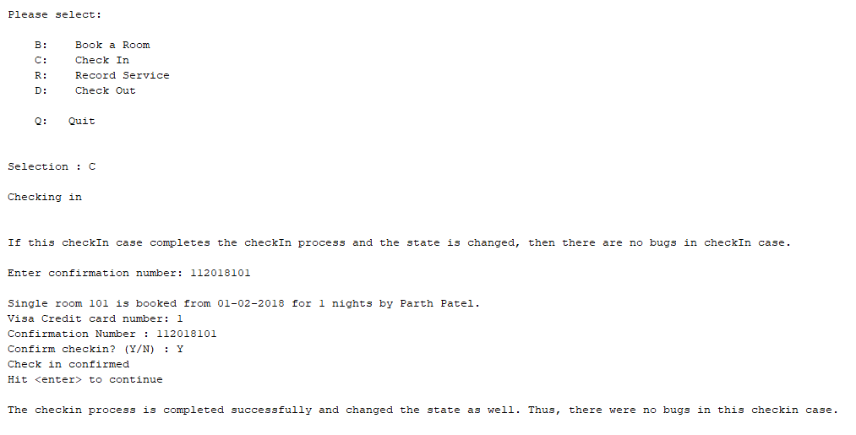

Thus, shown in above screenshot there are no bugs in checkin case.

The Record Service case should allow the service charges to be added to the room which is checked in and should display total at the end of the case. The screenshot of record service case testing is given below.

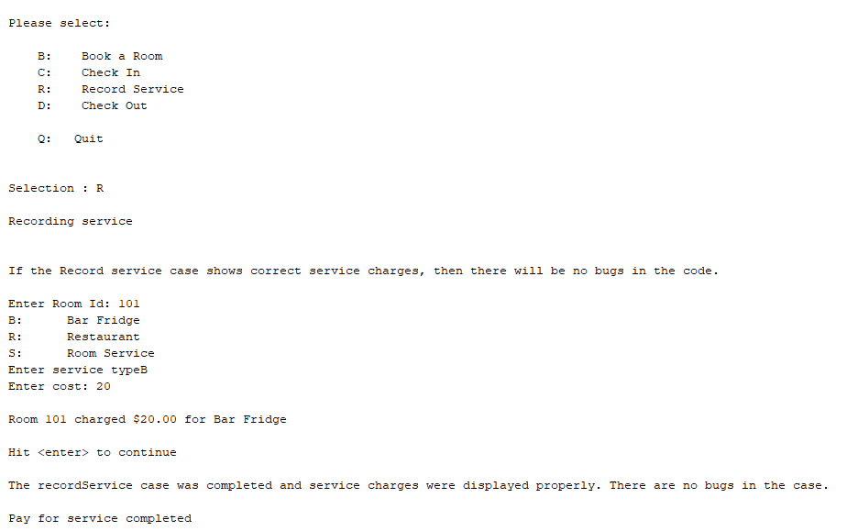

Thus, the record service case has no bugs.

The checkout case should allow the guest to checkout of the room and then should display the total of service charges to be paid by the guest and should change the state of the room to be checked out. The screenshot is given below.

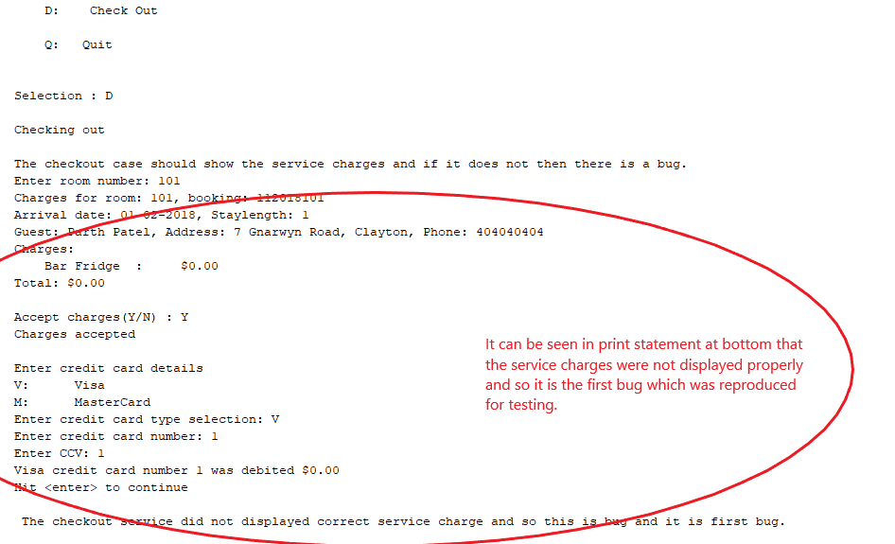

Thus, a simplified and automated test was made that reliably reproduced the bug. The bug can be found in above screenshot.

1. **Simplification stage for Bug 2:**

For this bug, I tried to again add service charges to the room 101 which was checked out in the previous stage. The screenshot can be seen below and also that room can be checked out again after finishing adding service charges. Thus, the bug is reported and reproduced and it is shown below.

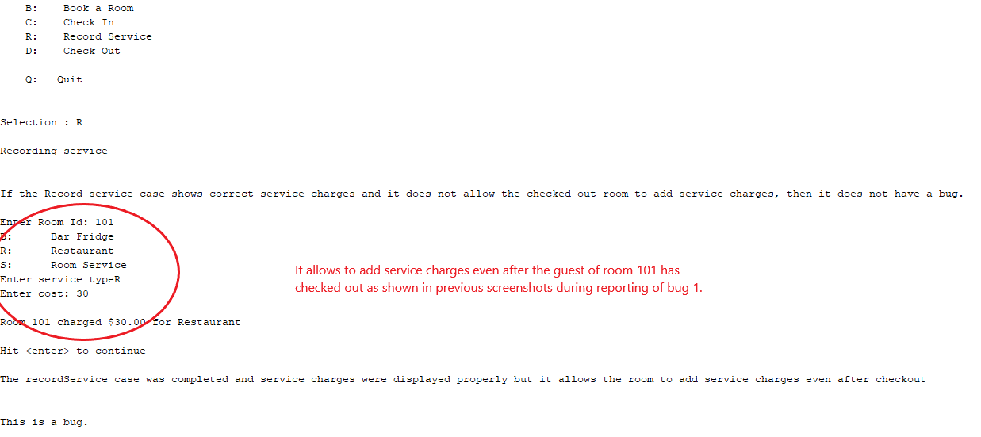

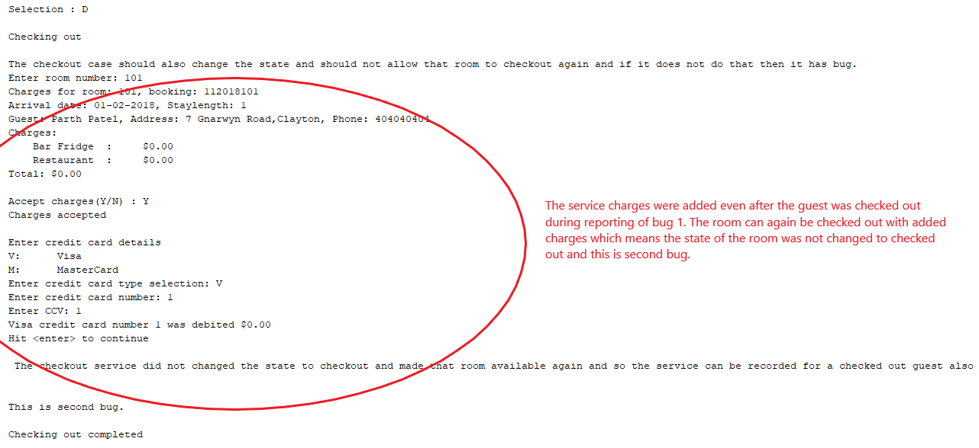

Thus, this was the simplification stage in which the bugs were reliably reproduced in different environment to test the buggy behavior.